Modernizing mission-critical enterprise applications
When creating new, large mission-critical applications, current scalable and elastic approaches should be applied. However, most existing enterprise applications were not built with asynchronous engines and event-driven approaches, and they don’t support scale-out and elastic architectures. In many cases, it is better to treat these applications as legacy systems to be integrated into updated (web-based or service-based) façades. This integration should be done while building a new asynchronous messageoriented integration system as a cross-channel organizer. The changes and updates to the established applications should focus on areas related to innovation (as in modern applications) or areas related to scalability and performance. However, when dealing with legacy systems, scalability can be achieved more easily by building front-end services and caches in the cloud (those previously mentioned façades) instead of rebuilding the whole mission-critical application from scratch. Then, in parallel, you can re-architect the internal systems behind the façades as budget and time allow.
This modernization is precisely one of the scenarios this guide focuses in the next sections.
Scenarios for custom large, mission-critical applications
The following sections discuss typical scenarios for custom large mission-critical applications:
• Scenario: Domain-Driven Subsystem (Bounded Context)
• Scenario: CQRS Subsystem (Bounded Context)
• Scenario: Communicating Different Bounded Contexts
• Scenario: Modernizing Legacy Mission-Critical Enterprise Applications
Scenario: Domain-Driven Subsystem (Bounded Context)
This scenario covers complex core-business subsystems. In this case, the word “complex” means systems that have a high volume of ever-changing domain/business logic that will be evolving for years.
While their presentation layer can vary (web, desktop, or modern mobile devices), the major volume of investment, design, and development is in the server/services side where the business/domain logic is usually placed.
This type of application (or subsystem) is characterized by having a relatively long life span and may need to absorb a considerable amount of evolutionary changes. Ongoing maintenance critical in these applications, so one of the most important priorities is to invest on architecture, design, and development principles that will ease maintenance and changes in the long term. If the application grows substantially, you want to ensure the minimum possible impact to the actual code. This is why monolithic approaches are the worst approach for these types of applications.
As mentioned earlier, in complex applications, the behavior of business rules (domain logic) is often subject to change, so the ability to modify, build, and perform isolated tests (unit testing and mocking) on domain logic layers in an easy and independent way is critical for a sustainable maintenance. Achieving this important goal requires minimal coupling between the domain model (entity model including logic and business rules) and the rest of the system’s layers (presentation layers, infrastructure layers, data persistence, and so on). For that purpose, persistence-ignorant models and decoupled designs based on abstractions are usually required in this context.
Additionally, because these long-term applications will usually have a very long life (several years at least), eventually, the technologies available will evolve or be replaced. Therefore, an important goal for long-term systems is to be able to adapt to infrastructure/technological changes with minimal impact to the rest of the application (domain model, domain rules, data structures communicated to other tiers [DTOs], etc.) Changes in infrastructure technology of an application (technologies for data access, service bus, security, operations, instrumentation, etc.) should have a minimal impact on higher-level layers in the application, particularly on the application domain model layer.
The trends in long-term application architectures are increasingly oriented to promote this decoupling between classes/objects and also between vertical areas (bounded contexts). Domain-Driven Design (DDD) is a prime example of this trend as an approach to developing complex functional software systems.
The DDD approach uses a set of techniques to analyze your domain and to construct a conceptual model that captures the results of that analysis. You can then use that model as the basis of your solution. The analysis and model in the DDD approach are especially well suited to building solutions for large and complex domains. DDD also extends its influence to other aspects of the software development process to help manage complexity.
The core principles in Domain-Driven Design are:
• Focus on the core domain
• Direct collaboration between “domain experts” and the development team
• Speak an ubiquitous language within an explicit bounded context (subsystem)
• Apply certain DDD architecture and proven design patterns
Therefore, DDD is much more than just a proposed architecture; it is a way of managing projects, team-work to identify an “ubiquitous language” based on “knowledge crunching.” This leads to continual interaction between the development team with domain experts to capture the important parts of the domain in the model, the ongoing search for better abstractions, refactoring, and improvement of the model. Developers’ knowledge of the domain grows over time, along with the domain experts’ ability to formalize or distill their domain knowledge.
When designing DDD logical architectures, a complex bounded context should be partitioned into layers. This design must be cohesive within each layer, but clearly must define the different layers within the system. Dependencies between objects should be based on abstractions. In addition to clearly delineate and isolate the domain model layer from the rest of the layers, like the infrastructure layers based on specific technologies (like data-access technologies). Everything must revolve around the domain, because “the domain layer is the heart of the software” in core-domain applications.
Hence, within a concrete bounded context, all the code related to the domain model (e.g., domain entities and domain services) should be placed in a single layer. The domain model should not persist/save itself, nor should it have direct dependencies to underlying technologies. It must exclusively focus on expressing the domain model (data and logic). The .NET Framework and Entity Framework ease this model implementation significantly when using POCO Code-First entities which are “persistent ignorant”.

This layering is similar to Figure 5-30 (following the trends of DDD architectural styles), where you could have additional bounded contexts with other different architectural approaches:
Simplified DDD Layered Architecture Within a Large Application
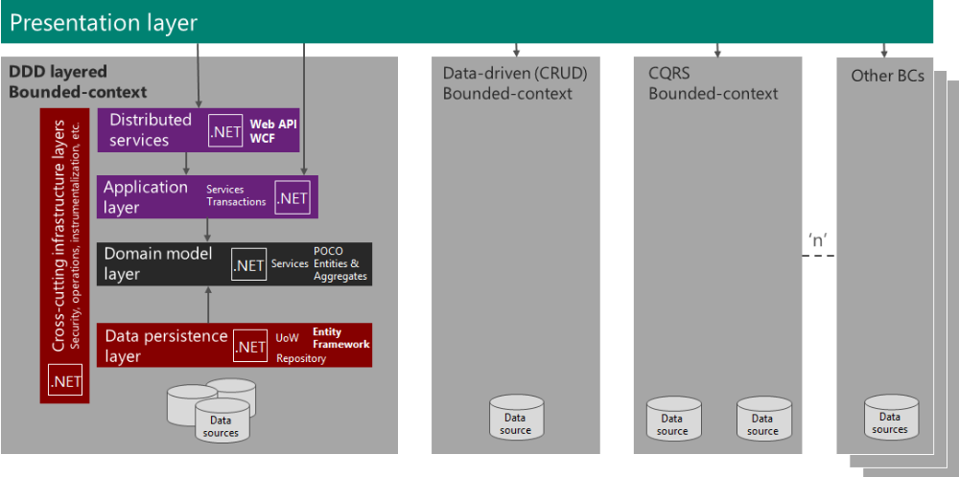
Figure 5-30
In this figure, the arrows represent dependencies between the different components and layers. The main difference between a DDD layered approach and a traditional top-down layered approach is that the domain model layer has no dependency to any other layer. This approach is based on abstractions (interfaces defined within the domain model layer and the related implementation classes are placed in other layers) and POCO entity models (like using Microsoft Entity Framework POCO entities and Code-First approach). That is why the domain model layer complies with the persistence ignorant principle regarding the dataaccess technologies you may use.
You should apply advanced approaches (like DDD or CQRS) only within the bounded contexts that focus on the core-domain of the application. Other collateral and simpler bounded contexts or subsystems may be implemented following data-driven and CRUD approaches, as shown in Figure 5-30.
The logical architecture shown in Figure 5-30 is the internal architectural approach. You may have top-level architectures orchestrating different services and other specific physical and infrastructure architectures (tiers and elastic services in private or public clouds, and so on) where you deploy those services, as shown in Figure 5-31 and Figure 5-32.
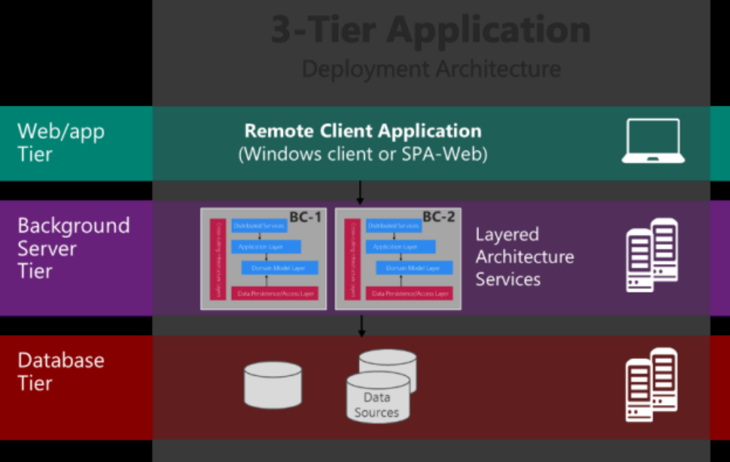
Figure 5-31
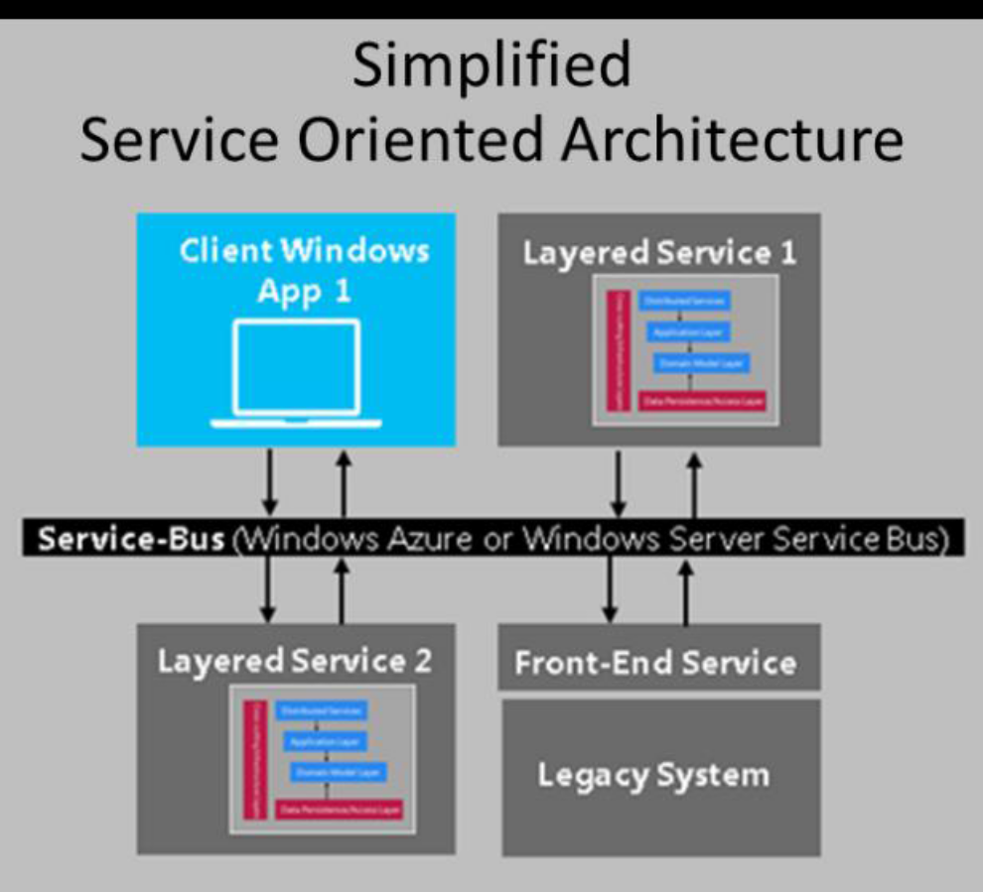
Figure 5-32
The services used by a 3-tier application can be composed of a number of bounded contexts. Each bounded context could have a unique data source, or they could share the same sources. It’s important that each bounded context has its own domain entity model, which usually means its own database schema.
In SOA, a service could match a bounded context, but it is not mandatory. A bounded context could also be composed by several services, or vice versa—a large service could be composed of several bounded contexts.
Bounded contexts and domain models
Bounded contexts deal with different aspects of the domain that represents a singular real-world (domain) concept. Bounded contexts are autonomous components, with their own domain models and their own ubiquitous language (concrete domain terms). They should not have any dependencies on each other at runtime and should be capable of running in isolation.
Bounded contexts give team members a clear and shared understanding of what has to be consistent and what can develop independently. Therefore, for each bounded context, you need to define a boundary around the delimited applicability and consistency of a particular model. Because of this, each bounded context usually has its own ubiquitous language that impacts its own model, so when you are talking about similar concepts and entities in several bounded contexts, they probably will have different attributes and potentially even different names and terms.
Decomposing a Traditional Model
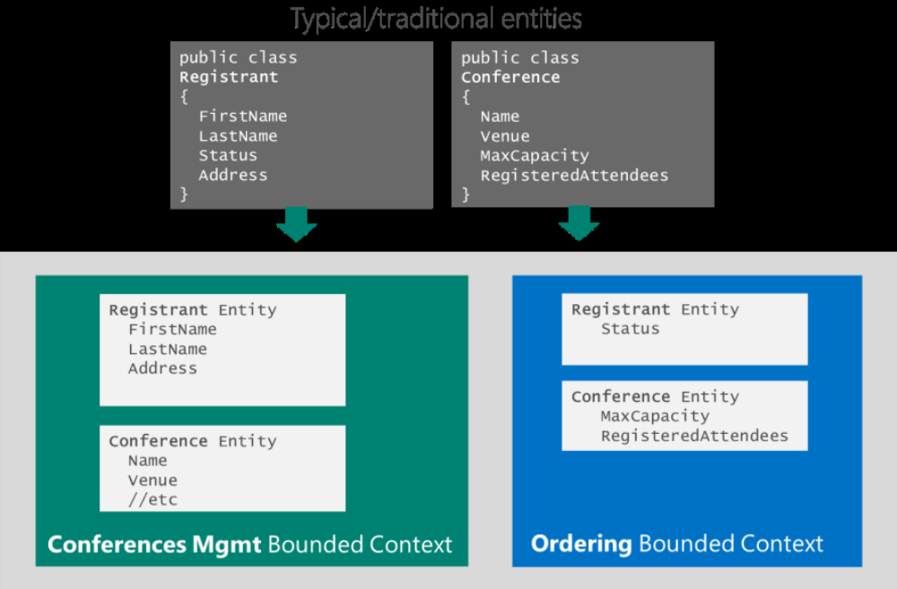
Figure 5-33

The pseudo entity diagram in Figure 5-33 shows a possible approach for a decomposition of traditional “upfront entities” (antipattern) into several bounded contexts (BCs). We must have a different model for each bounded context, but in many cases (like Figure 5-33), you have the same “concept” of entity in several models, using the same entity name, but probably with some different attributes.
In that example, we are splitting entities based on what attributes have to be consistent between them and impact to each other. For instance, the Registrant entity class in a hypothetical ConferencesManagementBC might have personal data like name, address, company data, and so on. But it is likely that the “Status” attribute makes more sense within the Registrant entity class in a different BC called, for instance, OrderingBC, because that attribute must be consistent with the conference RegisteredAttendees attribute. Therefore, BC boundaries must also be identified based on consistency between the data and which attributes impact other attributes and which ones don’t impact at all. For example, if you change the registrant’s FirstName, that won’t affect the conference registration attributes.
Sometimes you’ll need to have redundant attributes in different bounded contexts (try to minimize that). In those cases, you’ll have to deal and embrace “eventual consistency”. You also use eventual consistency between different Aggregates (consistent set of entities).
Also, taking a look at the required relationships between entities (grouping them in aggregates) is a good way to identify BCs. If some area of the initial model is really isolated from other areas in the potential application, that area should probably be a bounded context. Figure 5-34 illustrates this process.
Each bounded context and domain model is a different vision of the same reality (the domain), but for a different use and purpose.
Identifying Bounded Contexts
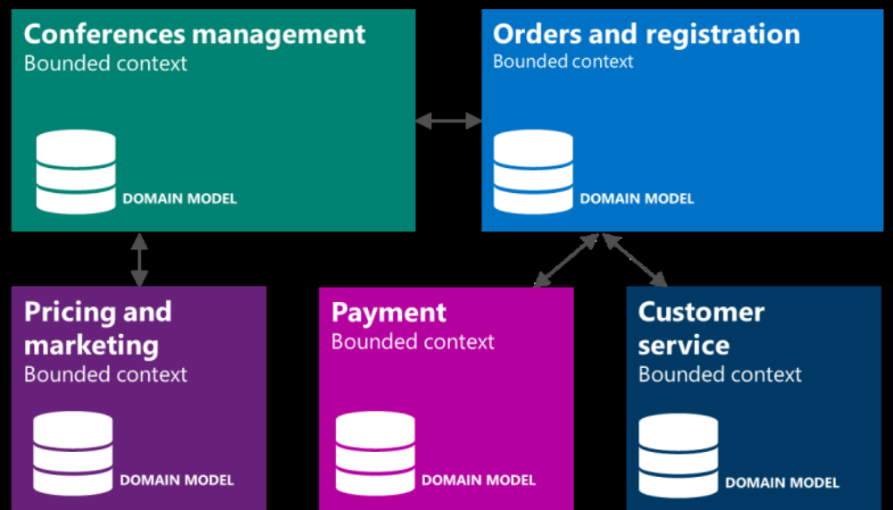
Figure 5-34

In order to understand it, there is a famous metaphor from Eric Evans saying that the world (the reality) is the
domain and any kind of world-map is a different BC with its own domain model.
When designing and implementing entities, it is also fundamental not to have an “anemic-domain model”
(anti-pattern) in DDD. Entity classes should have their own domain logic within the entity-class methods.
The implementation of Domain Model Entities using Microsoft development technology can be achieved
through different ways, though the way recommended by Microsoft is by using POCO (Plain Old CLR Objects)
entities (plain classes) that must comply with the “Persistence ignorant” principle (no dependencies from the entities themselves to infrastructure technology). Then, the model must be loosely-coupled to infrastructure data persistence technologies like Microsoft Entity Framework and Code-First approach mappings. Other lternatives include different O/RMs, like NHibernate, or custom approaches “from scratch” based on plain ADO.NET. But, in any case, the final dependencies (entities and repository contracts/interfaces) have to be within the model rather than in the infrastructure technologies. That is a crucial difference between DDD-layered architectures compared to regular layered architectures.
Implementing Domain-Driven Design patterns and other features with .NET
When applying Domain-Driven Design, each layer will usually implement different patterns like Domain Entity, Aggregate, Aggregate-Root, loose coupling between aggregates, Aggregate storage, Value-Object, Repository, Unit of Work, Domain Service, Factory, Domain events, eventual consistency and so on. (For detailed explanations of these patterns, please refer to the DDD references cited below.)

Figure 5-35 shows a suggested implementation path of typical DDD patterns and infrastructure features using Microsoft technologies.
Mapping from Patterns to Technologies
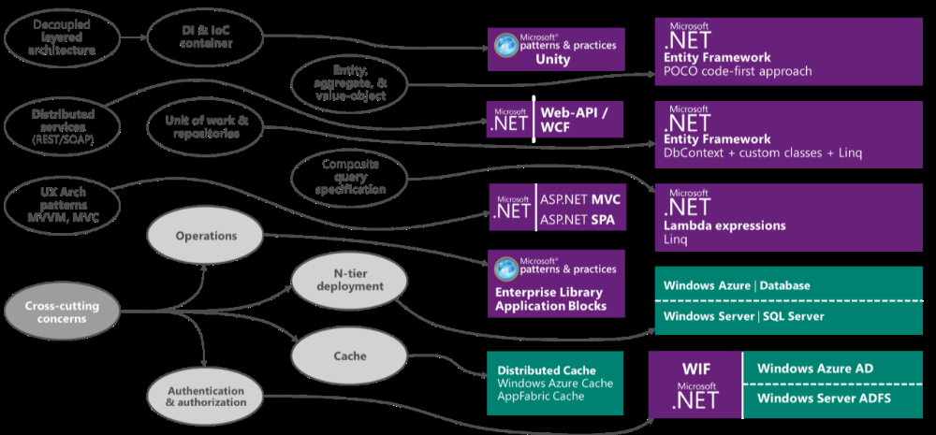
Figure 5-35
When using relational databases and implementing DDD patterns using .NET, the Domain-Entity, Aggregate, Aggregate-Root, Repository and Unit of Work patterns can be easily implemented relaying those patterns on any O/RM like Microsoft Entity Framework or any other O/RM. But, it depends on your application priorities and requirements. Other times, an Aggregate storage based on a NoSQL or document databases (non-relational, so no O/RM usage) is a better approach (e.g., for Event-Sourcing and aggregate events storage).
There is a wealth of resources regarding cross-cutting concerns, operations, security, and instrumentation subjects on MSDN.com and Microsoft Patterns and Practices documentation if you’d like to learn more.
References
The Anemic Domain Model http://www.martinfowler.com/bliki/AnemicDomainModel.html
POCO Entity classes (POCO: Plain Old
CLR Objects)
http://en.wikipedia.org/wiki/Plain Old CLR Object
Employing the Domain Model Pattern http://msdn.microsoft.com/en-us/magazine/ee236415.aspx
Entity Framework http://msdn.microsoft.com/en-us/library/jj591559 aspx
Event Sourcing http://codebetter.com/gregyoung/2010/02/20/why-use-event-sourcing/
Scenario: CQRS Subsystem (Bounded Context)
This scenario covers core-business subsystems based on CQRS (Command and Query Responsibility Segregation). CQRS is usually related to DDD, in particular, with contexts where users are competing for application resources and when the application requires high scalability (common in mission-critical applications, especially when facing an unlimited number of Internet users).

Betrand Meyer introduced the term “Command Query Separation” to describe the principle that an object’s methods should be either commands or queries. A query returns data and does not alter the state of the object; a command changes the state of an object but does not return any data. The benefit is that you have a better understanding what does, and what does not, change the state in your system.
CQRS takes this principle a step further to define a simple pattern.
"CQRS is simply the creation of two objects where there was previously only one. The separation occurs based upon whether the methods are a command or a query (the same definition that is used by Meyer in Command and Query Separation: a command is any method that mutates state and a query is any method that returns a value)."
—Greg Young
Figure 5-35 shows a typical application of the CQRS pattern to a portion (BC) of an enterprise system. This approach shows how, when you apply the CQRS pattern, you can separate the read and write sides in this portion of the system. CQRS can be a good fit for many Windows Azure cloud scenarios.
CQRS Approach Within a Large Application
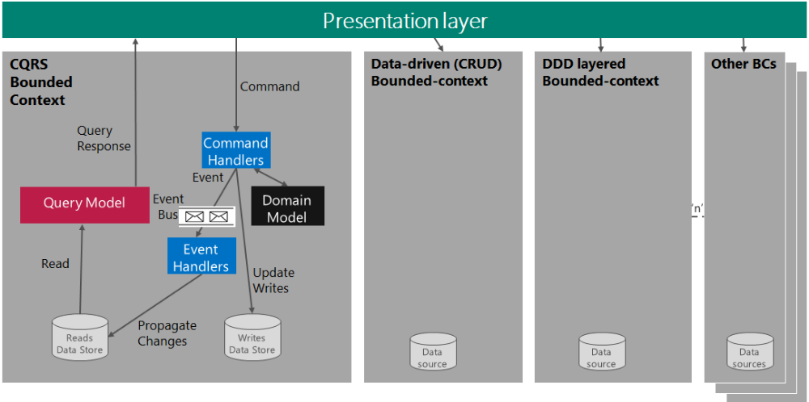
Figure 5-36
References
CQRS Journey guidance – by
Microsoft patterns & practices
http://msdn.microsoft.com/en-us/library/jj554200.aspx
CQRS on Windows Azure http://msdn.microsoft.com/en-us/magazine/gg983487.aspx
Greg Young http://cqrs.files.wordpress.com/2010/11/cqrs documents.pdf
Udi Dahan http://www.udidahan.com/2009/12/09/clarified-cqrs/

Scenario: Communicating Different Bounded Contexts
Bounded contexts should not have dependencies on each other at runtime—they should be capable of running in isolation. A large/complex application can have any number of interrelated bounded contexts, each one with its own domain model, as shown in Figure 5-37. In a large application, there can be dozens of bounded contexts.
Large Application with Many Subsystems
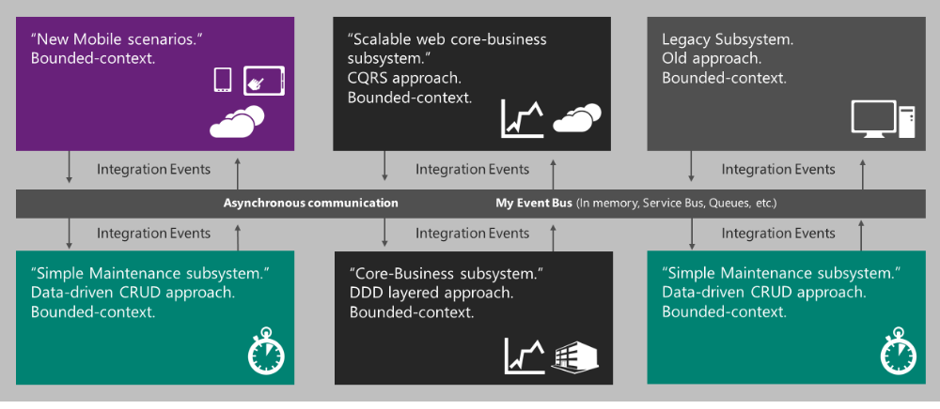
Figure 5-37
However, BCs are a part of the same overall system or larger application and they need to exchange data with one another. Even when they should be isolated from other BCs, information changes, and events that happen in one BC will impact others. Use asynchronous communication base on events for this type of inter-BC communication. The bounded context can respond to events that are raised outside of the bounded context. Bounded context can publish events that other bounded contexts may subscribe to. Events (one-way, asynchronous messages that publish information about something that has already happened) enable you to
maintain the loose coupling between your bounded contexts. These events can be referred to as integration events to indicate an event that crosses bounded contexts.
When using integration events and asynchronous communication between bounded contexts, it doesn’t necessarily mean a SOA or using a service bus. This communication could also be based on any type of event-bus that can be implemented using different infrastructure technologies. Possibilities for an event-bus implementation include a simple in-memory bus, an inter-process communication event bus using named-pipes (within the same server, if that is enough for our objectives or for Proof of Concept purposes), message queues like MSMQ (Microsoft Message Queuing), or going for a full service bus like Windows Server Service Bus or Windows Azure Service Bus (or a third party service bus, like NServiceBus) for production systems.
The way of dealing with BCs integration events is almost identical to the way you deal with events in CQRS. The events (simple message of any type) must be created after something has occurred in the domain storage (e.g., an update in the domain storage). The event will be named in past tense and will be published into the event bus. It is fundamental that the event bus must support a publish/subscription mechanism, so after publishing a message event in the event bus, any BC who was subscribed to the event bus will get that event and perform an action in order to propagate it to its own domain model. Based on that approach, you will have eventual consistency between all the bounded contexts.

Context maps
A large system, with dozens of bounded contexts and hundreds of different integration event types, can be difficult to understand. Context maps are valuable records of which bounded contexts publish which integration events, and which bounded contexts subscribe to which integration events.
Additionally, once you get to a large number of bounded contexts or integration event types, a service bus capable of publish/subscription mechanisms becomes very convenient.
Relationships between contexts
The different relationships that exist between two or more contexts depend greatly on the degree of communication between the various teams in each context and the degree of control you have over them. For example, you may not be able to perform changes in certain contexts, such as in the case of a system in production or a discontinued system.
Shared kernel
This approach fits better for ‘Green field’ scenarios, where you are actually building an end-to-end application. In this case, when you have two or more contexts where the teams who are working on them can communicate fluently, it is interesting to establish a shared responsibility for certain objects that all the contexts use in common. An example might be certain shared areas of the same Domain Model shared by two or more bounded contexts. These objects become what is known as a shared kernel for all the contexts. In order to make a change on any object of the shared kernel, it is necessary to have the approval of all the teams who own the contexts involved. Promoting a good communication between the different teams is critical as they are sharing the same Domain model area (although those bounded contexts can also have their own different domain models, additionally).
Scenario: Modernizing Legacy Mission-Critical Enterprise Applications
This scenario is very important in large mission-critical systems, as the systems have a very long, evolving life. There can be many legacy and/or critical applications in the enterprise that need to be modernized. Usually the first step should be modernizing the external face of those systems or parts of it. Adding a Microsoft Windows Store mobile application (Windows 8 or Windows Phone) opens the application to new experiences and scenarios. A good example is a Host Application or a large legacy ERP system—it often isn’t possible to migrate or modernize the whole system.
To modernize legacy systems, start creating service façades that wrap those legacy systems and expose them to new scalable systems like persistent caches in the cloud in order to scale out and consume services from many new mobile clients. This approach moves limited scalability in a legacy system to hypothetically unlimited scalability in cloud systems for new channels and users (e.g., direct customer access).
However, in a long-term, large, core-business application there might be new bounded contexts (subsystems) that need to be consistent with the older legacy systems. Here too, because of consistency required, it’s necessary to communicate and integrate new bounded contexts with older legacy subsystems. This requires certain approaches like the anti-corruption layer.
The Anti-Corruption Layer
This is probably the most important pattern regarding bounded contexts integration, especially when faced with teams that are poorly communicating. This pattern is also important if one of the bounded contexts to integrate is a legacy bounded context, which can have a different ubiquitous language (and therefore completely different models), and you do not want that to affect your newer bounded contexts. For this type of situation you can implement an anti-corruption layer, an intermediate layer between the different contexts that performs the required translations (related to model objects and also to integration events).

Modernizing Established Systems Using the
Anti-Corruption Layer
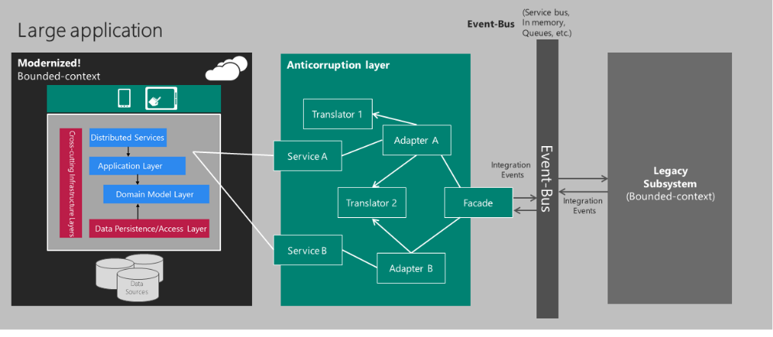
Figure 5-38
An anti-corruption layer consists of three types of components: adapters, translators, and façades. First, a façade is designed to simplify the communication with the other context and exposes the minimum functionality as possible. It is important to understand that the façade should be defined in terms of the other context’s model elements; otherwise you would be mixing the translation with the access to the other system. After designing a façade, an adapter is placed to modify the interface/events of the other context and adapt it to the interface expected by our context. Finally, you use a translator to map the elements of our context to the expected elements of the other context façade (or vice versa).
The anti-corruption layer is also critical for managing the integration events. Bounded contexts are independent of each other and may be modified or updated independently. Such modifications may result in changes to the events that a bounded context publishes. These changes might include introducing a new event, dropping the use of an event, renaming an event, or changing the definition of event by adding or removing information in the payload. A bounded context must be robust in the face of changes that might be made to another bounded context. The anti-corruption layer is responsible for verifying that incoming integration events make sense. You can also use the anti-corruption layer to translate incoming integration events.
The implementation of an anti-corruption layer can be custom (plain .NET). This is the initial approach. For more complex contexts, or when the legacy subsystem to be extended is a market-product (like SAP or any other ERP, etc.), the integration and translations can be continuously evolving and become very complex. In this situation, you might consider using a specific integration platform (like Biztalk Server)—which offers more than 25 adapters linking to market-packages and a robust messaging infrastructure—on top of Windows Server or Windows Azure (IaaS), and can also link to Windows Azure Service Bus.

6. Conclusions
There are too many combinations of approaches, technologies, architectures, and patterns to apply in business applications. This guidance tries to position a number of approaches based on mainstream application priorities, but it should not be taken as rigid, prescriptive guidance precisely because of the large number of contexts in business applications. There may be logical exceptions to this guidance, like small and medium-sized business applications that are not very data-driven but should be more domaindriven due to ever-changing domain rules. Or vice versa—collateral subsystems or bounded contexts that are clearly following a data-driven approach though they might be a part of a large mission-critical application.
The main goal of this guide is to position Microsoft technologies in different approaches driven by application and business priorities. How you categorize your application completely depends on your application context and specific domain. The main purpose of this segmentation is simply to provide a way to envision and organize different approaches and technology positions.
Custom application development is oftentimes more of an art than a science—that’s why there’s no prescriptive truth to follow. The approaches, techniques, and technologies to use depend on the application context, the real domain to solve, and on the developer team context and skill set.

Appendix A: Silverlight migration paths
As explained in this guide, RIA containers are being replaced gradually by other alternatives with broader device support (HTML5) or better device integration (native development). However, your choice and timeframe may be different based on your current investments and needs. Over time, this will involve more HTML5 and native applications and less RIA containers, but you are in control of the final decision and timeframe.
If you are currently using Silverlight, you can make this transition gradually at the timeframe of your choice. It is also possible that some portions of the application need to be coded in HTML5 and/or Silverlight. Since Silverlight is a plug-in, it can be used within HTML content. If your scenario is more suited for a native application, Silverlight also provides a good bridge for platforms supporting .NET/XAML, such as WPF in the desktop, Windows Store Apps .NET model, or even (with the solutions explained previously in this guide) non-Microsoft devices. Because the latest Silverlight version is supported for 10 years, you can make that transition gradually while still using the mature and stable solution Silverlight provides.
If you have a major application that has a monolithic architecture—i.e., the back end tightly integrated with the front end—you should decouple these two parts of the system, so that multiple front ends (HTML4, HTML5, Silverlight, native mobile) can connect to the same back end.
Additionally, there are some applications whose requirements are still only covered by RIA containers solutions (for example, video content protection), and therefore you should continue with the existing investment.
Because of the breadth of different scenarios, and the variety of application types, context, and priorities, the migration paths in Table A-1 are recommended.

